**SPRINT-3**

| **Team ID** | **PNT2022TMID07580** |
| --- | --- |
| **Project** | **IoT Based smart crop protection system for agriculture** |

STEP1: Simulated program to get the random values.

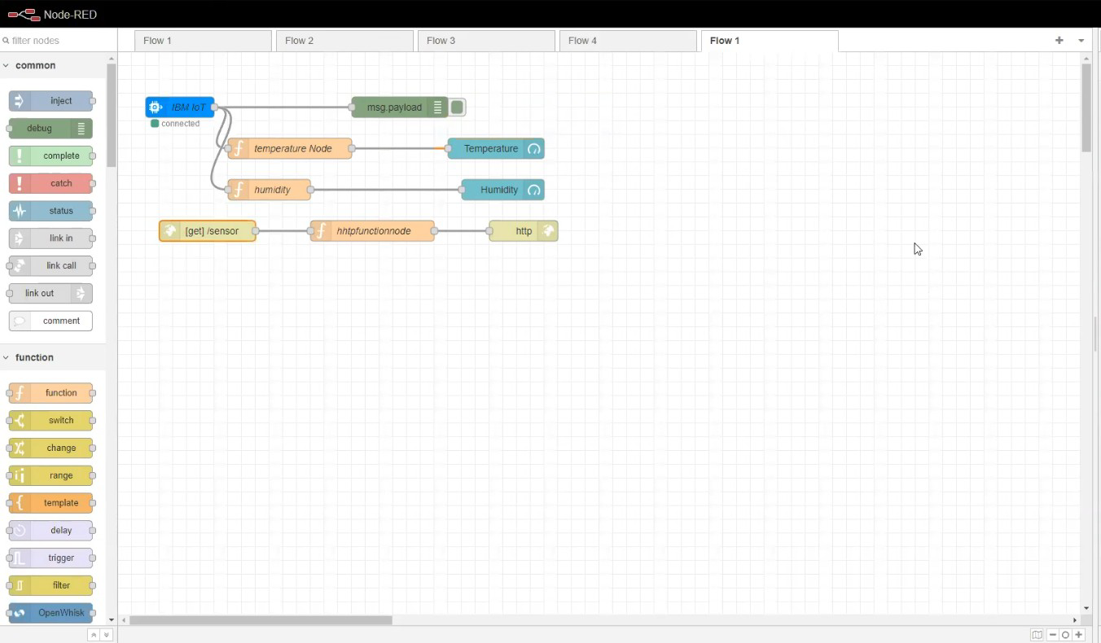

STEP2: Generate debug message from IBM Watson IoT Platform and connect the nodes.

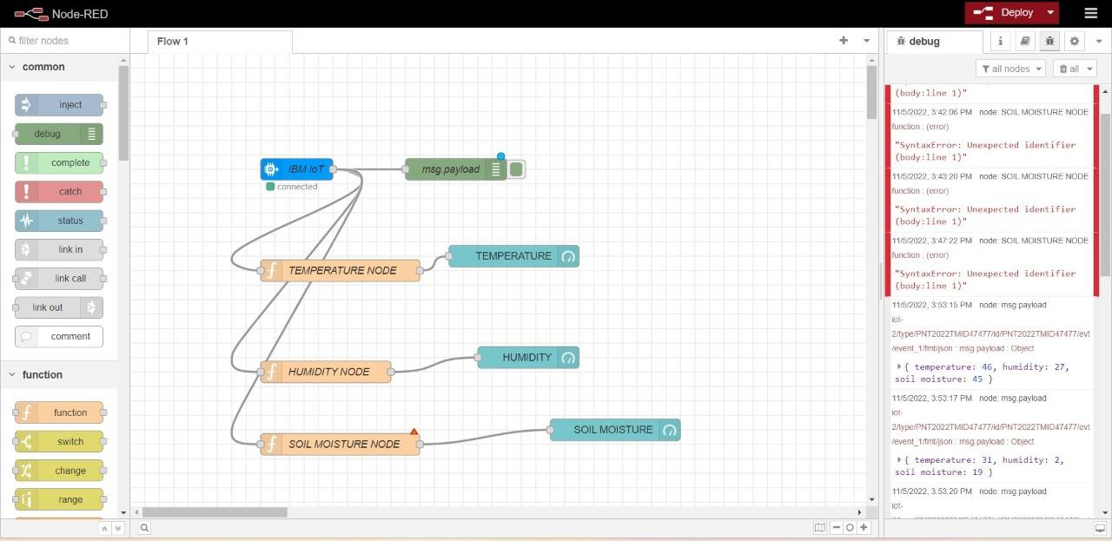

STEP3: Generate the some output from recent events.

